**Old Dubbo Gaol - Accessibility Guide**

For further information please email odg@dubbo.nsw.gov.au or call (02) 6801 4460

**Getting Here**

Old Dubbo Gaol is located at 90 Macquarie Street, Dubbo, NSW. The site is on the main street of Dubbo. (See Image 1 below)

Free 1-Hour parking is available on Macquarie Street.

Mobility Parking is available on Macquarie Street, in front of Old Dubbo Gaol.

For other parking options see the CBD Parking Map included at the end of this guide.

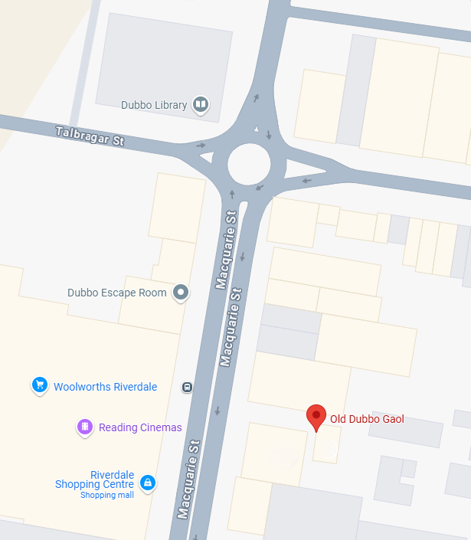

**Image 1.Old Dubbo Gaol, 90 Macquarie Street, Dubbo, NSW 2830**

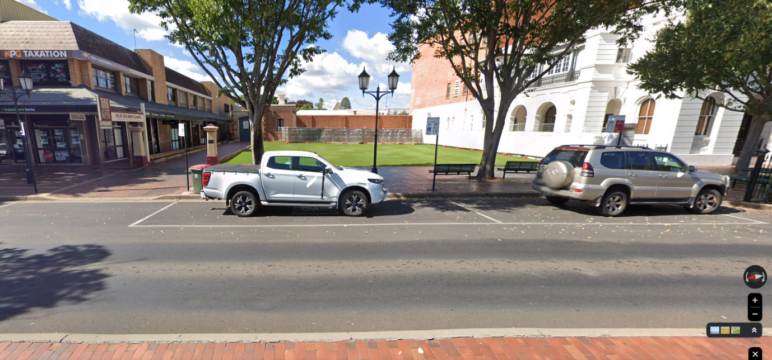

**Image 2. View of mobility street parking in front of Old Dubbo Gaol**

**Access Programs**

Old Dubbo Gaol offers several programs to assist with accessing the site.

* Audio narration tour - information presented on our map recorded into an audio format.
* Sensitivity hours - available upon request for start or end of the day. We work with you, adjusting lighting and sound to your comfort levels.
* Regular tours and performances - are conducted in accessible locations. These locations will be indicated upon your arrival.

**Traversing Old Dubbo Gaol**

Making your way around the Old Dubbo Gaol can be difficult due to the site’s age. Here are some things to keep in mind:

* **A door to a building

  AI-generated content may be incorrect.**Admissions area – There is a large step up into the room. Our staff are more than happy to meet you in the foyer to complete your admissions process.

**Image 3.** **Admissions area from front gates**

**Image 4. Ticketing and step into the room**

* Uneven steps – the floors and grounds are uneven through Old Dubbo Gaol. We encourage guests to take care as they move through the site.
* Wheelchair access - both cell blocks have ramp access into the buildings, however cell doorways are narrow.   
  The average width of cell openings is 61cm  
  Please see the accessibility map for suggestions on navigating the site.

**Image 5. Ramp access into cell division**

* Toilets - Ambulant Bathroom is present on site. Access upon request.
* Baby Changing rooms - Old Dubbo Gaol has a change table available upon request.
* Assistance Animals – All assistance animals are welcome on site.

**Access Services**

* Companion cards are accepted when presented at our front counter. This includes our night tour activities.
* Discounted rates are offered on presentation of a concession card.
* A private room can be unlocked on request. This area has seating, air-conditioning and a microwave available. There is a small step into and out of this room.

**Fire and First Aid**

* Emergency evacuation maps are posted around Old Dubbo Gaol.
* A metal gate with a sign on a shelf

  AI-generated content may be incorrect.First aid is available from the admissions desk. Please notify staff so they may assist and keep record of any and all incidents.

**Image 6 Description: First Aid Kit and AED in Admissions area**



